Introduction on Python

Contents
Introduction on Python 1
Introduction 1
Advantages of Python 1
Tech-Stack for end-to-end Full Stack Pipelines and Importance of Python as a stand-alone language 2
Front-end 2
Backend 2
Databases 2
Devops 2
Cloud Integration 2
Microservices Pipeline 2
Devops 3
Conclusion 3

Introduction
- Python is a high-level cross-platform language.
- It was created by Guido Van Rossum in 1991.
- It is simple, readable, reduces developer effort.
Python has a foundation for data science, AI, automation, devops, cloud scripting.
- It is backed by one of the largest open-source communities.

Advantages of Python
- It is readable.
- It has a short development time.
- It has a large ecosystem works with libraries like numpy, pandas, fastAPI, pyspark.
- It is cross-platform: Works across MAC, Linux, Windows.
- It has a massive community and endless libraries.
- It is easy to integrate with rest API, cloud SDK, automation frameworks.
- It has a cloud resource automation, AI/ML pipelines, ETL (Extract-Transform-Load), Data engineering, API-driven automation, application scripting.
- It integrates with azure, AWS, GCP, Snowflaks, Databricks, docker and Kubernetes.

Advantages
Advantages
WORA
Object-Oriented
Cross-platform

Tech-Stack for end-to-end Full Stack Pipelines and Importance of Python as a stand-alone language
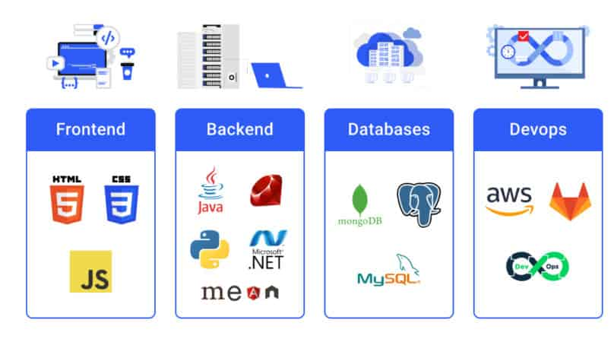

Front-end
HTML, CSS, JS

Backend
Java, Python, .NET

Databases
MongoDB, MySQL

Devops
Docker Kubernetes

Cloud Integration
AWS, Azure, GCP

Microservices Pipeline

Python ===== Docker

Devops

Devops pipeline = Python = CI/CD Pipeline

Conclusion
- Python is the top language for AI/ML and pipelines.
- Python is the trending language in the market.
- Python guides the steps to become relevant in the software industry.

